Deep Acceptor Polarons in a-TeO₂ and Hydrogen-induced Instabilities in IGZO

John. Robertson^{1,2}, Hailing. Guo^{1,3}, Yuzheng Guo³, and Ruyue Cao^{1,4}

¹ Engineering Dept, Cambridge University, Cambridge CB3 0FA, UK
²Engineering Dept, Liverpool University, UK
³ Wuhan University, Wuhan, China
⁴ Chinese Academy of Sciences, Beijing, China

The talk is in two parts. There is a lack of p-doped amorphous semiconductors with moderate deposition temperature for back-end of line (BEOL) semiconductor processing. Undoped 𝛽-TeO₂ is a high mobility p-type semiconductor¹. However, there has been no experimental proof that p-type doping leads to conductive acceptor states, as E_{F} of undoped a-TeO₂ lies near midgap². Recent GGA studies on As_{Te} sites found shallow p-type states³, but the unit cell was too small. Larger 216-atom cells using hybrid HSE functionals presented here find deep states, Fig. 1. The acceptors form deep, non-doping configurations with angular polaronic distortions (Fig. 2) with broken As-O bonds. This is more complex than simpler vacancy defects⁴, Fig 2. The band edge energies fall outside the limits for doping^{3,4}. The distortions arise because the network has a low mean coordination of 2.4, the floppy limit for such lattices⁵.
We also study hydrogen-induced instabilities in the n-type InGaZn oxide semiconductor, of major technological interest for BEOL processing. Some Metal-H and oxygen-H configure-ations proposed in Bang⁶ are evaluated using GGA+U and HSE calculations, Fig. 3.

- A Zavabeti, et al, Nature Electronics 4 277 (2021)
- J Shi, .. K H L Zhang, App Phys Lett 122 101901 (2022)
- J Robertson et al, App Phys Lett 124 212 101 (2024)
- Z Xiao.., H Hosono, Chinese Physics Lett 42 016103 (2025)
- H He, M F Thorpe, Phys Rev Lett 54 2107 (1985)
- J Bang, S Matsuishi, H Hosono, APL 110 232105 (2017)

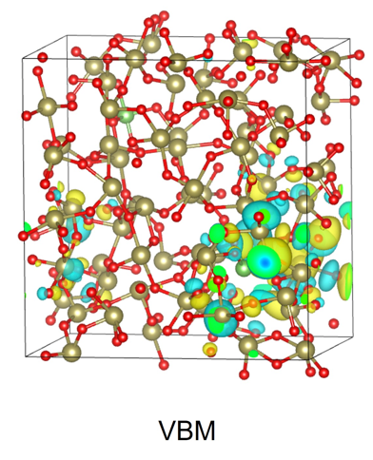

Fig. 3 Partial density of states of M-H and M-OH configurations in amorphous IGZO.
Fig. 2 Atomic structure and localised acceptor state of As_{Te}.
Fig. 1. GGA, green dots. HSE, red dots for various p-dopant sites.

