Mechanism of Epitaxial Growth of Rutile-type GeO₂ by PLD

T. Suzuki¹, K. Sakaban¹, K. Ide¹, T. Katase¹, H. Hiramatsu^{1,2}, H. Hosono¹, and T. Kamiya¹
¹ MDX Research Center for Element Strategy, Institute of Integrated Research,
Institute of Science Tokyo, Yokohama, Japan
² Materials and Structures Laboratory, Institute of Integrated Research,
Institute of Science Tokyo, Yokohama, Japan
Email: suzuki.t.dv@m.titech.ac.jp

Ultra-wide band gap oxide semiconductors, with band gap energies (E_{g}) exceeding those of GaN and SiC, have been extensively studied for next-generation power electronics and deep ultraviolet optoelectronics applications. Although β-Ga₂O₃ (E_{g} = 4.8–4.9 eV) has been the primary focus, it has a critical limitation in the difficulty of achieving p-type doping. In contrast, rutile-type GeO₂ (r-GeO₂) with E_{g} = 4.68 eV has been emerged as a promising material owing to its potential controllability of both p- and n-type conduction, which is predicted theoretically by first-principles calculations^{[1]}. The extraordinarily short O–O distances in the r-GeO₂ crystal structure enhance O 2p – O 2p antibonding interactions, raising the energy level of the valence band maximum and making hole doping feasible^{[2]}. Although the number of reports on epitaxial growth of r-GeO₂ films has been increasing^{[3,4]}, synthesis of high-quality epitaxial films remains challenging due to competing polymorphs, such as α-quartz and amorphous phases. These phases hinder effective doping with aliovalent ions.

In this study, we systematically investigate effects of deposition conditions, especially focusing on oxygen pressure (P_{O2}) and growth temperature (T_{g}), on growth of GeO₂ films by pulsed laser deposition (PLD). We successfully controlled the growth phase of GeO₂.

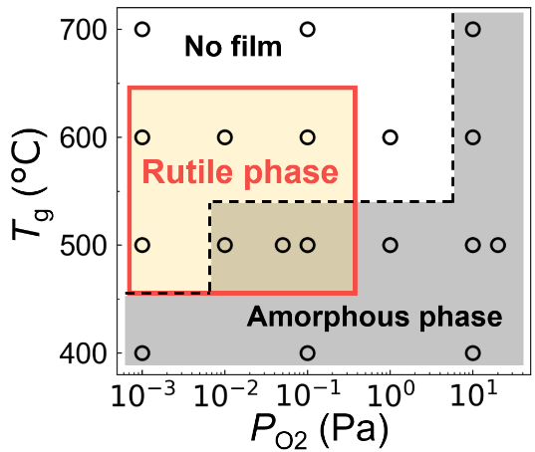
Figure shows the growth phase diagram of GeO₂ films grown by PLD as a function of T_{g} and P_{O2}. Epitaxial films of r-GeO₂ are obtained at T_{g} = 500 – 600℃ under low P_{O2} ≤ 10⁻¹ Pa, while the α-quartz phase does not appear under any growth conditions. However amorphous phase coexists under higher P_{O2} ≥ 10⁻² Pa at T_{g} = 500℃, and only amorphous phase is formed under lower T_{g} ≤ 400℃ and higher P_{O2} ≥ 1 Pa. On the other hand, severe re-evaporation of the film occurs with increasing T_{g} and decreasing P_{O2}, and finally no film growth is observed at 700℃. These results indicate that low P_{O2} is inevitable to obtain pure r-GeO₂ film; however, re-evaporation of the GeO₂ film becomes serious at the same time. These competing phenomena not only complicate phase stabilization but also hinder precise control of chemical composition particularly when dopant ions are introduced. We will discuss it in more detail at the conference.
Figure. Growth Phase diagram of GeO₂ film deposited by PLD at different T_{g} and P_{O2}.

[1] S. Chae, et al., Appl Phys Lett, 114, 102104, (2019). [2] C. Niedermeier et al. J.Phys.Chem., 124, 25721, (2020). [3] S. Chae, et al., Appl Phys Lett, 117, 072105, (2020). [4] H. Takane, et al., Appl Phys Lett, 119, 062104, (2021).

