**Industry-Scaled DC Sputtering of SnZnOx: Toward Indium-Free Transparent Electrodes for Solar Cells**

M. Härtel1, K. Mayer-Stillrich1, A. Steigert1, B. Stannowski1,

*1 Photovoltaics Competence Center Berlin, Helmholtz-Zentrum Berlin, Berlin, 12489, Germany*

Transparent conductive oxides (TCOs) are used in many optoelectrical devices, such as solar cells or light-emitting diodes. Often, these devices require TCOs to be deposited at low temperatures (e.g., OLEDs, silicon heterojunctions, or perovskite/silicon tandem cells) without compromising their excellent optoelectrical properties, which limits the selection of suitable materials. Therefore, the most widely used TCOs are indium-based. However, indium’s scarcity and increasing demand for optoelectronic devices will likely lead to supply challenges and rising costs[1]. Herein, we report on a study of SnO₂-based TCO, namely tin-zinc oxide (ZnO < 8 wt.%), as a promising indium-free alternative. The deposition was done in an in-line DC sputter system from ceramic tube targets. The optoelectrical properties of the tin-zinc oxide (SnZnOx) were optimized by tuning deposition parameters, namely the oxygen concentration in the argon process gas and the radiative substrate heater’s temperature, as well as the post-deposition annealing treatment temperature. Fig. 1a) shows the resistivities (𝜌) of SnZnOx films measured by 4-point-probe under varying oxygen concentration and the effect of the annealing of the same samples. As can be seen, in the as-deposited state, a minimum 𝜌 of ~4.85 mΩcm was reached for an oxygen concentration of 3 %. The 𝜌 of SnZnOx films with both higher or lower oxygen concentration were higher. At annealing temperatures of 150 °C and 210 °C the minimum 𝜌 was further reduced to 3.57 mΩcm, and 2.13 mΩcm, respectively. Interestingly, the more oxygen was added, the higher the impact of the annealing on the 𝜌 of the films. With that in mind, the effect of applying heat during the sputtering process was also explored (see Fig. 1b)). It was found that when setting the heaters to 600 °C (which yield a substrate temperature of < 200 °C), the 𝜌 of an as-deposited film was about the same, 2.47 mΩcm, as a sample that was deposited without using heaters (heaters off) and annealed at 210 °C. Interestingly, the 𝜌 of films that were deposited while heating during the sputtering process were, independent of the annealing, significantly smaller than films that were deposited without heaters. The lowest 𝜌 achieved in this study was 1.59 mΩcm at 3.5 % oxygen content, 450 °C heater temperature, and annealed at 210 °C. This is still approximately three times higher than a typical ITO or IZO film, which reaches 𝜌 of well below 0.5 mΩcm, and ~ 50 % higher than the 𝜌 of an reactive plasma deposited (RPD) SnOx achieved by Koida et al., but it shows the great potential of that material and of sputtering as a feasible deposition method [2]. Additionally, the indium-free TCOs were characterized by means of Hall-effect, spectrophotometry, and x-ray diffraction. In the next step we will implement these TCOs in solar cells.

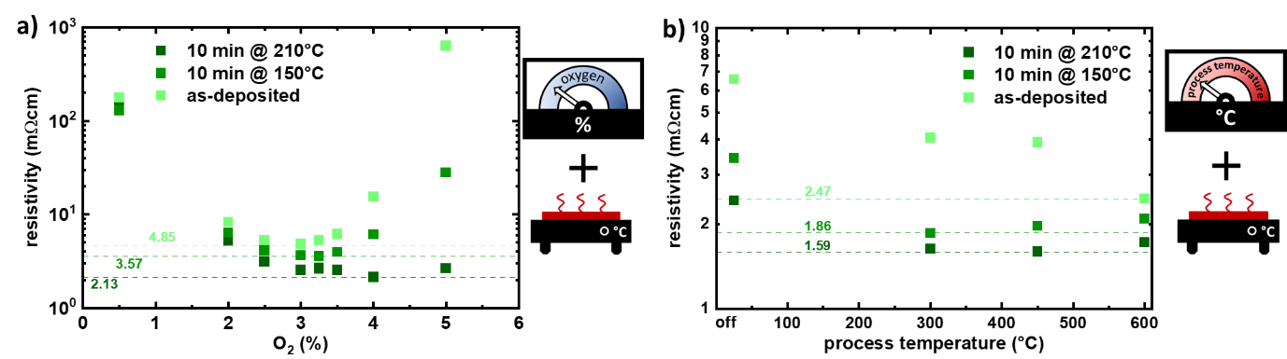

*Resistivities of SnZnOx films deposited at a DC power of 2 kW, using an industry-scaled (0.6 m) ceramic tube-target, implemented in the multifunctional cluster tool KOALA*

[1] L. Wagner *et al.*, *Joule*, vol. 8, no. 4, pp. 1142–1160, 2024, doi: 10.1016/j.joule.2024.01.024.

[2] T. Koida *et al.*, *Chem. Mater.*, vol. 36, no. 14, pp. 6838–6848, 2024, 10.1021/acs.chemmater.4c00719.