Fast solution of inverse problems on IGZO transistor characterization via tandem neural network

K. Ide¹, M. Kimura¹, A. Shimizu¹, T. Katase¹, H. Hiramatsu^{1,2}, H. Hosono¹, and T. Kamiya¹
¹ MDX Research Center for Element Strategy, Institute of Integrated Research,
Institute of Science Tokyo, Yokohama, Japan
² Materials and Structures Laboratory, Institute of Integrated Research,
Institute of Science Tokyo, Yokohama, Japan
E mail: ide.k.ab@m.titech.ac.jp

Operation characteristics of In-Ga-Zn-O thin-film transistors (TFTs) are influenced by semiconductor properties of their channel layers such as defect distributions and electron transport properties, which are altered largely by process conditions [1]. Accordingly, it is important to analyze these semiconductor properties for feedback to the process conditions to improve TFT performances. TCAD device simulators are useful tools for simulating TFT characteristics from input of semiconductor properties and device structures (forward problem). In contrast, there was no approach to solve the inverse problem that calculates semiconductor properties directly from TFT characteristics; therefore, non-linear optimization using TCAD simulations is employed but it needs large numbers of trial-and-error calculations and is expensive in time. Such inverse problem process is expected to speed up by machine learning (ML) approaches. It is, however, challenging due to the multivaluedness in the relation between semiconductor properties and TFT characteristics; different semiconductor properties may give nearly the same TFT operation characteristics.
This study develops a neural network (NN) model to solve multivalued inverse problems and applies it to the fast analysis of semiconductor parameters from transistor characteristics. Conventional inverse NNs have been utilized for such problems by simply swapping descriptors and objective variables; however, they struggle to predict semiconductor parameters that exhibit ranges exceeding several orders of magnitude. We employ a tandem NN architecture that connects a pre-trained forward NN and an inverse NN, where the total loss function includes both the prediction errors of semiconductor parameters and the reconstruction errors of transistor characteristics, each weighted appropriately. As a result, we successfully performed inverse analysis to estimate physically plausible semiconductor parameters that accurately reproduce transistor characteristics. Our results enable real-time and autonomous analysis and feedback control of semiconductor and device fabrication processes, helping accelerate the development of new semiconductor materials and devices.
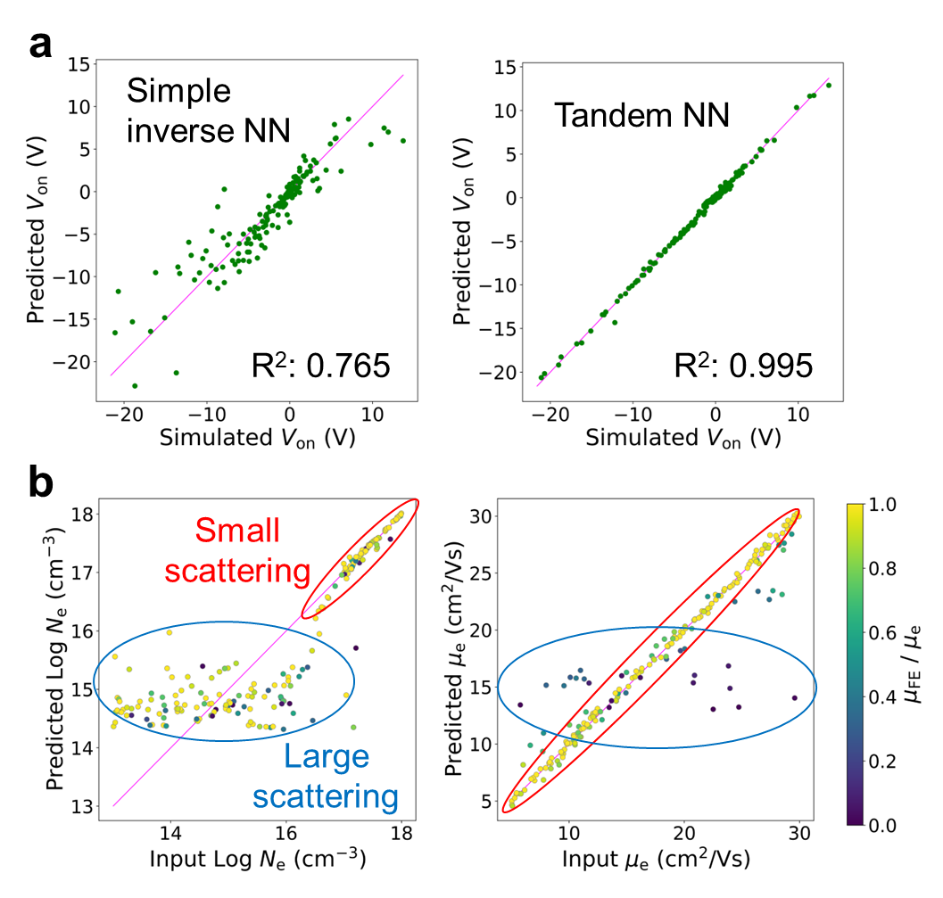
Figure: Parity plot showing reproduction accuracies of TFT parameter, Von, from obtained semiconductor parameters with simple inverse NN and Tandem NN
[1] K. Ide, K. Nomura, H. Hosono and T. Kamiya. “Electronic Defects in Amorphous Oxide Semiconductors”, Physica Status Solidi (A) Applications and Materials Science vol. 216 (2019).

