Spray pyrolysis of ternary oxides – the case of Cu_{x}CrO₂ and a-ZnSnO₃
C. Cooling¹, A. Zhussupbekova², I.V. Shvets², K. Fleischer^{1,2,*}
¹ School of Physical Sciences, Dublin City University, Dublin, Ireland
² School of Physics, Trinity College Dublin, Ireland
*correspondence @ Karsten.fleischer@dcu.ie

Spray pyrolysis is a popular method for the low-cost synthesis of oxides and other compounds in thin film form. Here we discuss several limitations and pitfalls of the method when working with ternary and quaternary compounds. Specifically, we outline how precursor solubility, thermal decomposition, but also desorption of intermediate species from the sample surface govern the spray pyrolysis growth process.
We present optical real time measurements of sample growth for ternary transparent conducting oxides (TCO; p-type Cu_{x}CrO₂ and n-type a-ZnSnO₃) illustrating stark difference between the growth rate of binary oxides and ternary oxides using the same precursors and growth conditions.
We illustrate how the several steps of spray pyrolysis affect the stoichiometry transfer from the solution to the thin film and how the choice of instrument geometry and nozzle type affect the electrical and optical properties of the TCOs. For the ZTO system we present how changes in the spray setup and nozzle type can significantly improve the film properties when using low-cost chloride precursors which were previously found unsuitable in an air blast nozzle system. When used in conjunction with medical grade ultrasonic nozzles these precursors can provide good films.
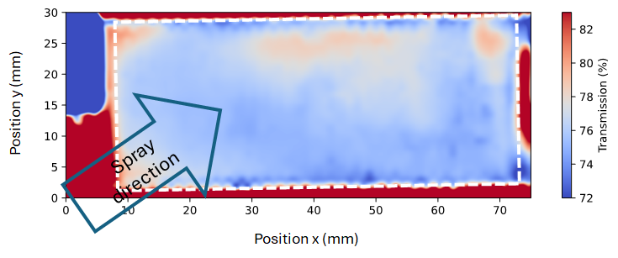
Figure 1: Example UV-VIS spectrophotometry map (1mm sampling) showing the average transmission in the photon energy range of 1.5 to 3.0eV for a ZTO sample on glass grown with a single ultrasonic nebulizer and chloride precursors (SnCl₂, ZnCl₂). Small transmission variations arise from thickness variations and differences in surface roughness (leading to differences in scattering). The dashed line indicates the usable sample area unaffected by gas flow disturbances and shadowing by holding clamps.

