**High sensitivity H2 gas sensor gas sensor utilizing large on/off ratio of amorphous In-Ga-Zn-O thin film transistor**

A. Shimizu1, K. Ide1,2, T. Katase1,2, H. Hiramatsu1,2, H. Hosono1 and T. Kamiya1,2

*1 MDX Research Center for Element Strategy, Institute of Integrated Research,*

*Institute of Science Tokyo, Yokohama, Japan*

*2 Materials and Structures Laboratory, Institute of Integrated Research,*

*Institute of Science Tokyo, Yokohama, Japan*

*E mail: shimizu.a.af@m.titech.ac.jp*

Amorphous oxide semiconductors, (AOSs) such as amorphous In-Ga-Zn-O (*a*-IGZO), are widely used as channel materials in thin film transistors (TFTs) for flat-panel displays [1]. Applications of AOS TFTs are extended beyond displays e.g. to gas sensors. *a*-IGZO TFTs can attain large on/off ratios more than 10 orders of magnitude, so the *a*-IGZO TFT gas sensors are expected to achieve ultra-high sensitivity. *a*-IGZO TFT gas sensors have been applied to detection of NO2 [2] and volatile organic molecules [3] so far. However, only *a*-IGZO thin film has been used for H2 gas detection [4], and there have been a few reports using *a*-IGZO TFTs. In this study, we fabricated *a*-IGZO TFTs with good switching characteristics at high temperatures where H2 gas sensor operates and evaluated the gas sensor performances.

We measured *a*-IGZO TFT performance at 250oC in air and a mixing gas of H2 and air. The H2 concentration of the mixing gas was fixed at 100 ppm. First, we measured an initial I-V curve in air. Then we introduces the H2 gas and measured I-V curves cyclically for 5 times at one-minute intervals. After the measurements in H2, we stopped H2 flow and measured I-V curves for 20 times. Fig. (a) shows transfer curves of *a*-IGZO TFTs in air without and with H2 flow. After the H2 introduction, the turn-on voltage (*V*on) shifts to the negative *V*G. This shift would be caused by H2 adsorption on the *a*-IGZO surface, which increases the carrier density and the conductivity of *a*-IGZO [4]. Fig. (b) shows the *V*G dependece of H2 gas sensitivity calculated from the ratio of *I*D at each *V*G in air without and with H2 flow. The gas sensitivity reached a maximum value of >106, indicating that a high sensitivity H2 gas sensor can be realized by applying good switching of *a*-IGZO TFTs. Fig(c) shows the time variation of *V*on. The *V*on shifts in response to the flow change of H2 flow, confirming that the change in *V*on is related to H2 adsorption and desorption.

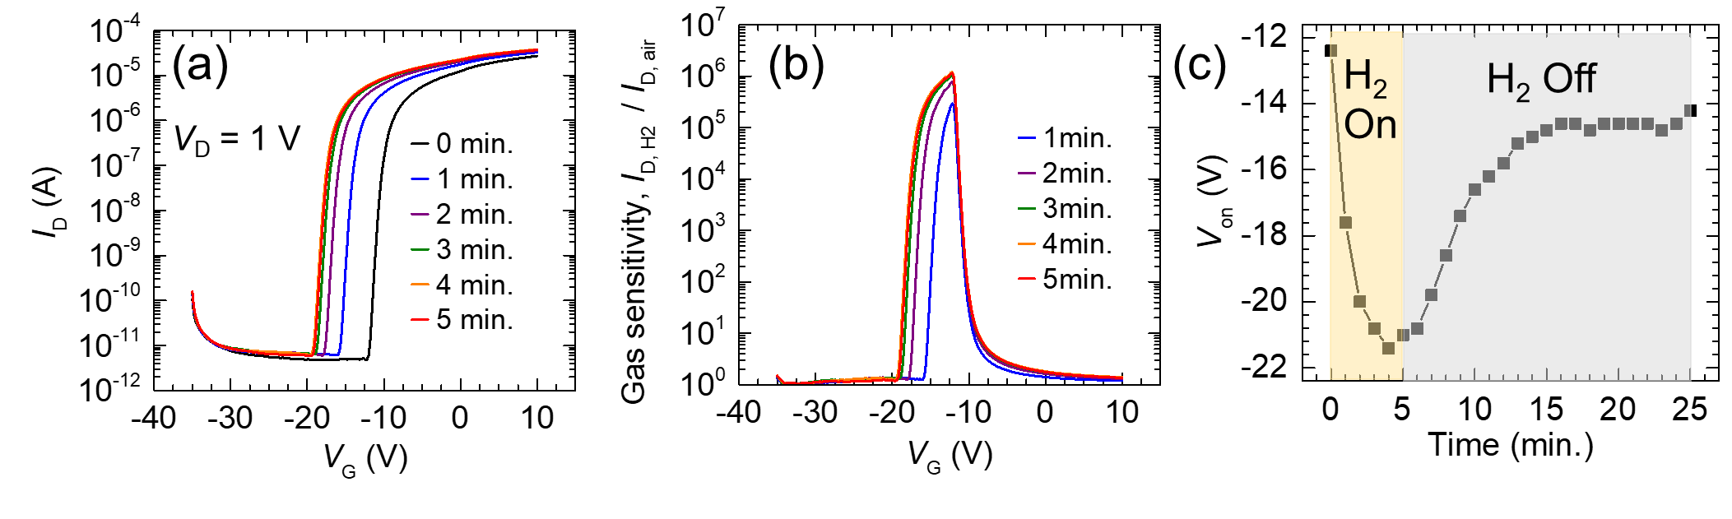Fig. 1(a) Changes of *a*-IGZO TFT transfer curve by flowing H2 gas. (b) *V*G dependence of H2 gas sensitivity calculated from the ratio of *I*D in air and H2. (c) Time dependence of *V*on by On/Off switching of H2. Yellow and gray regions indicate H₂ on and off, respectively.

[1] K. Nomura, et.al., *Nature* 432 (2004) 225. [2] K. Kim, et al., *ACS Appl. Mater. Interfaces*, 2018, 10, 10185−10193. [3] H. Im et. Al., *ACS Sens.* 2023, 8, 3370−3379 [4] D.J. Yang et al., Sensors and Actuators B 171– 172 (2012) 1166– 1171